# MAS/COMP111 Unity Assignment

**Name**: Yuk (Ricky) Leung

**Student ID**: 44674082

Unity features used in this assignment:

|  |  |  |
| --- | --- | --- |
| **Effect** | **Marks** | **Check if used** |
| An **outdoor** section built using the Terrain editor or GAIA) | 25% | Check |
| An **indoor** section built using Unity primitives (cubes, spheres, etc) and/or ProBuilder (25%) | 25% | Check |
| A **First Person controller** with which the player can navigate the scene. | - | Check |
| Appropriate [textures](https://docs.unity3d.com/Manual/Shaders.html) on the indoor section | 5% | Check |
| Textures with [normal maps](https://docs.unity3d.com/Manual/StandardShaderMaterialParameterNormalMap.html) | 5% | Check |
| A simple single-state [animation clips](https://docs.unity3d.com/Manual/animeditor-UsingAnimationEditor.html) | 5% | Check |
| A [multi-state animation](https://docs.unity3d.com/Manual/AnimationStateMachines.html) that responds to trigger or mouse events | 5% | Check |
| Direct [light sources](https://docs.unity3d.com/Manual/LightSources.html) beyond the default Directional Light | 5% | Check |
| [Baked indirect lighting](https://docs.unity3d.com/Manual/LightMode-Baked.html) in the Indoor section | 5% | Check |
| Use of [light-probes](https://docs.unity3d.com/Manual/LightProbes.html) for dynamic indirect lighting | 5% | Check |
| Use of [reflection-probes](https://docs.unity3d.com/Manual/ReflectionProbes.html) and reflective surfaces | 5% |  |
| Appropriately chosen [post-processing effects](https://docs.unity3d.com/Manual/PostProcessingOverview.html) | 5% | Check |
| Use of [multiple cameras](https://docs.unity3d.com/Manual/CamerasOverview.html) (e.g. overlaid cameras or rendering to a texture) | 10% | Check |
| [Particle systems](https://docs.unity3d.com/Manual/PartSysWhatIs.html) | 10% | Check |
| Objects controlled by [physics](https://docs.unity3d.com/Manual/PhysicsSection.html) | 5% | Check |
| Using [joints](https://docs.unity3d.com/Manual/Joints.html) | 5% | Check |
| Appropriate 3D spatialised [audio sources](https://docs.unity3d.com/Manual/AudioOverview.html) | 5% |  |
| Using [reverb zones](https://docs.unity3d.com/Manual/class-AudioReverbZone.html)**,**[effects](https://docs.unity3d.com/Manual/class-AudioEffectMixer.html) and [filters](https://docs.unity3d.com/Manual/class-AudioEffect.html) | 5% |  |
| **TOTAL:** |  |  |

**Note:** Totals greater than 100% will be rounded down.

On the following pages you should indicate where each of the above features appear in your game, using screenshots to direct the marker. You will not get marks for a feature if your marker cannot easily locate it within your world.

## 1. Terrain

**Features used**:

* An **outdoor** section built using the Terrain editor
* Textures with [normal maps](https://docs.unity3d.com/Manual/StandardShaderMaterialParameterNormalMap.html)

**Where in Hierarchy**

* /Terrain

**Description**:

My terrain consists of 2 parts. The first is a bumpy grassland and the second is a beach. The grassland is more elevated than the beach but there is a more gradual downward slope in the middle of the grassland area that allows easy traverse between the two parts of the terrain. The grassland has a grass texture with a grassy normal map applied to it as well as grass billboards are all over it. The beach has a sand texture applied and is connected to water. The underwater area of my terrain has a different darker sand texture applied.

**Screenshot**:

The Outdoor area on the Terrain:

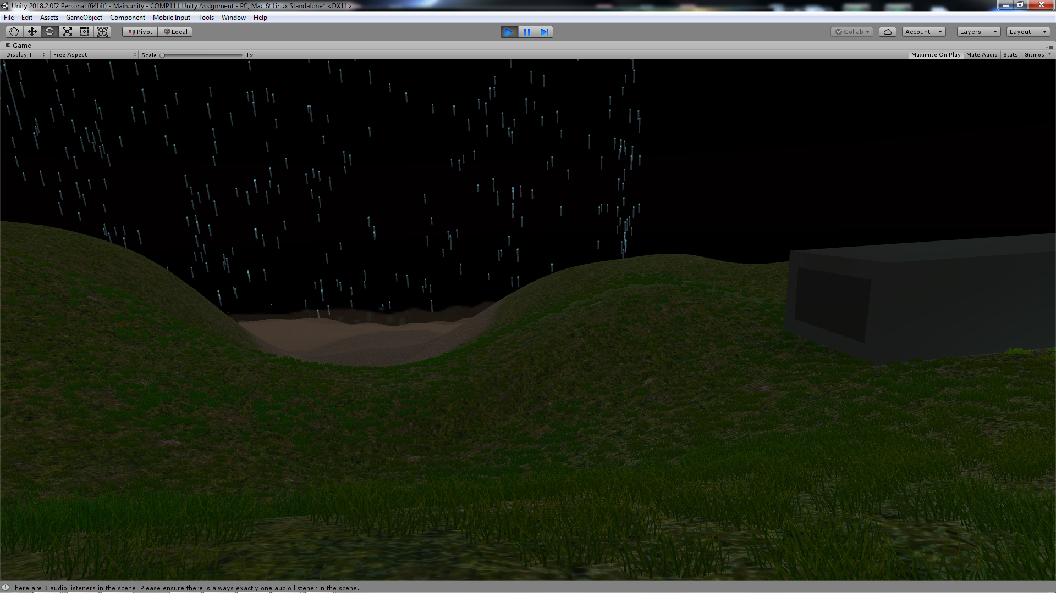

## 2. Building with ProBuilder and Primitives

**Features used**: (The order of this list follows the Description instead of the Rubric)

* An **indoor** section built using Unity primitives and/or ProBuilder
* Appropriate [textures](https://docs.unity3d.com/Manual/Shaders.html) on the indoor section
* A **First Person controller** with which the player can navigate the scene.
* A [multi-state animation](https://docs.unity3d.com/Manual/AnimationStateMachines.html) that responds to trigger or mouse events
* Objects controlled by [physics](https://docs.unity3d.com/Manual/PhysicsSection.html)
* Using joints

**Where in Hierarchy (respectively)**

* /Shipping Container
* /FPSController
* /Shipping Container/Interior/Tunnel Door & /Shipping Container/Interior/Tunnel Terminal
* /Shipping Container/Exterior/Door (Hinge)

**Description**:

(Indoor) My indoor area is the interior of a shipping container. It has 2 parts as well. The first is the exterior which is the shape of a shipping container. It has a grey texture. The second part is the interior which houses a structure that resembles a Fallout 4 Decontamination Tunnel. This tunnel uses a cyan-coloured texture.

(FPSController) The player controller starts at the start of the tunnel.

(Multi-state Animation) At the end of the tunnel, there is a red button which when looked at and clicked on, it will be depress downwards then revert to its original position. On the left, the cylinder object that is part of the Tunnel is also animated to by the same trigger to compress itself towards the start of the tunnel, effectively moving out of the player’s way. This sliding door and the red button are my use of multi-state animations.

(Physics and joints) Just past the sliding door, it would seem that there’s a wall blocking the player but in truth, this portion of the wall is where physics and joints were used – this is a swinging door which can be pushed open by the player. This door automatically closes with the use of dampeners. A further use of physics is a door stopper (/Shipping Container/Interior/Stationary/Tunnel Arch 4th/Door Stopper) which prevents the Swinging door from being stuck at an odd position if the player pushes the door inwards from the outside. This door stopper is invisible to the player through culling mask.

**Screenshot**:

The Indoor Area (the Red Button at the end of the Tunnel is visible from the start):

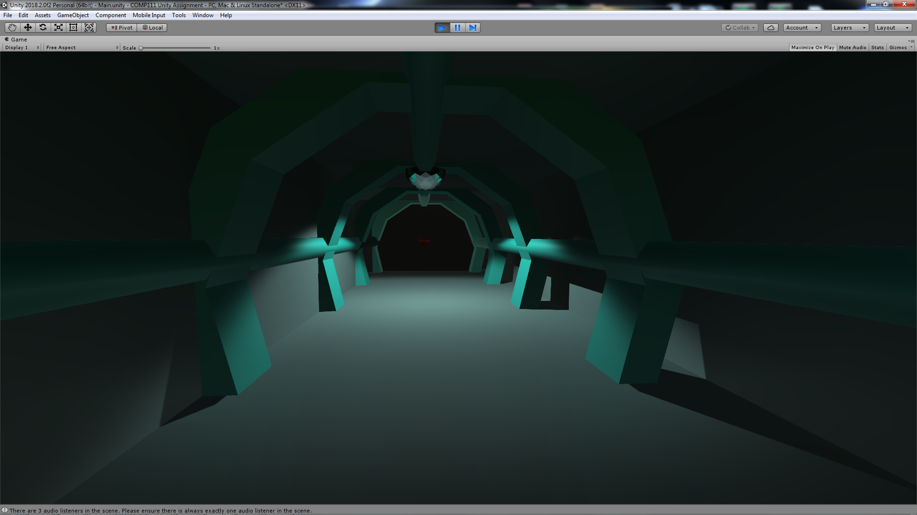

The Red Button, the Sliding Door and the Swinging Door:

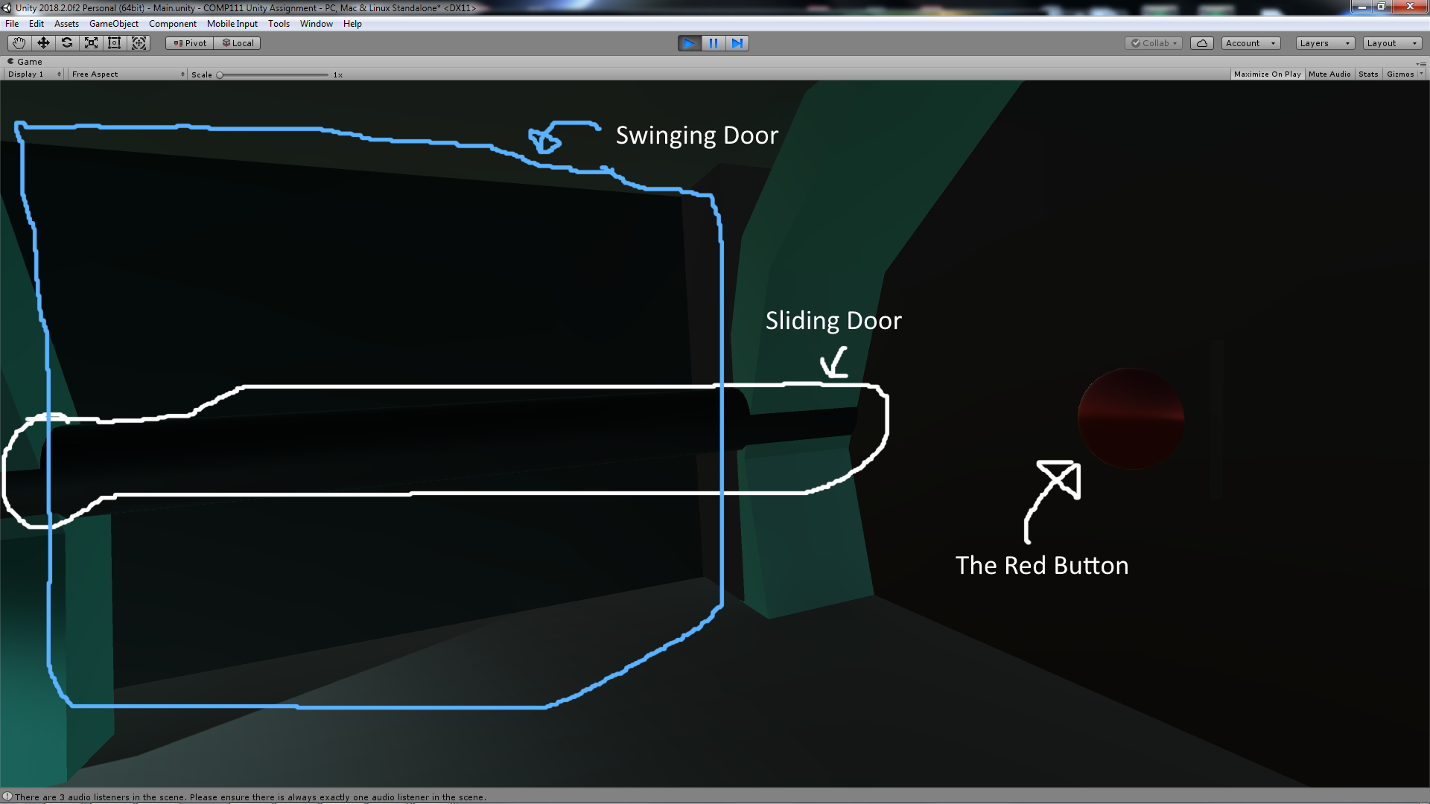

The Open-State of both Door:

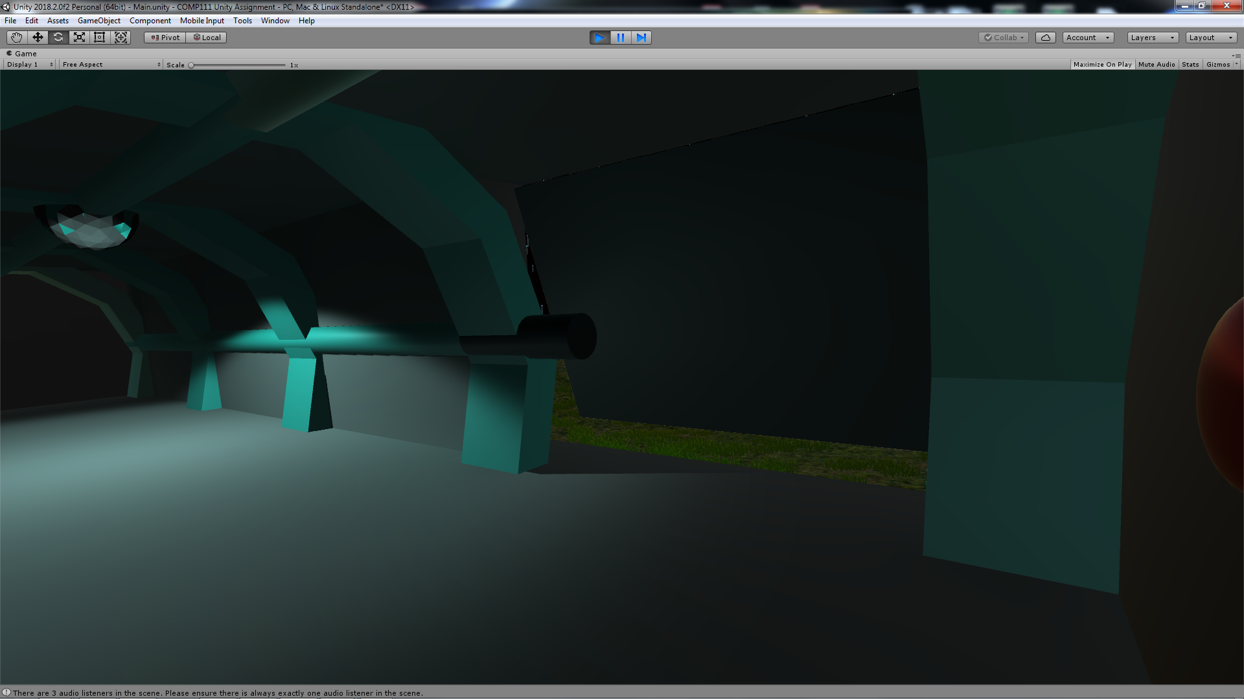

## 3. Lighting

**Features used**:

* Direct [light sources](https://docs.unity3d.com/Manual/LightSources.html) beyond the default Directional Light
* [Baked indirect lighting](https://docs.unity3d.com/Manual/LightMode-Baked.html) in the Indoor section
* Use of [light-probes](https://docs.unity3d.com/Manual/LightProbes.html) for dynamic indirect lighting
* Use of [reflection-probes](https://docs.unity3d.com/Manual/ReflectionProbes.html) and reflective surfaces

**Where in Hierarchy**

* /Shipping Container/Interior/Stationary/Illumisphere (Lightbulb)

**Description**:

For my indoor baked lighting, I’ve used a Icehegon from the ProBuilder to form the physical shape of my lightbulb. It uses a spot light and it’s placed directly under the actual lightbulb in order to cast a visible shadow of the moving player’s capsule. The lightbulb has a texture of a highly reflective surface and makes use of the reflection-probe that is placed directly underneath the lightbulb. There are also light probes at all corners of the Shipping Container’s Interior.

**Screenshot**:

The Illumisphere (lightbulb) from a short distance, showing its reflective surfaces and light properties:

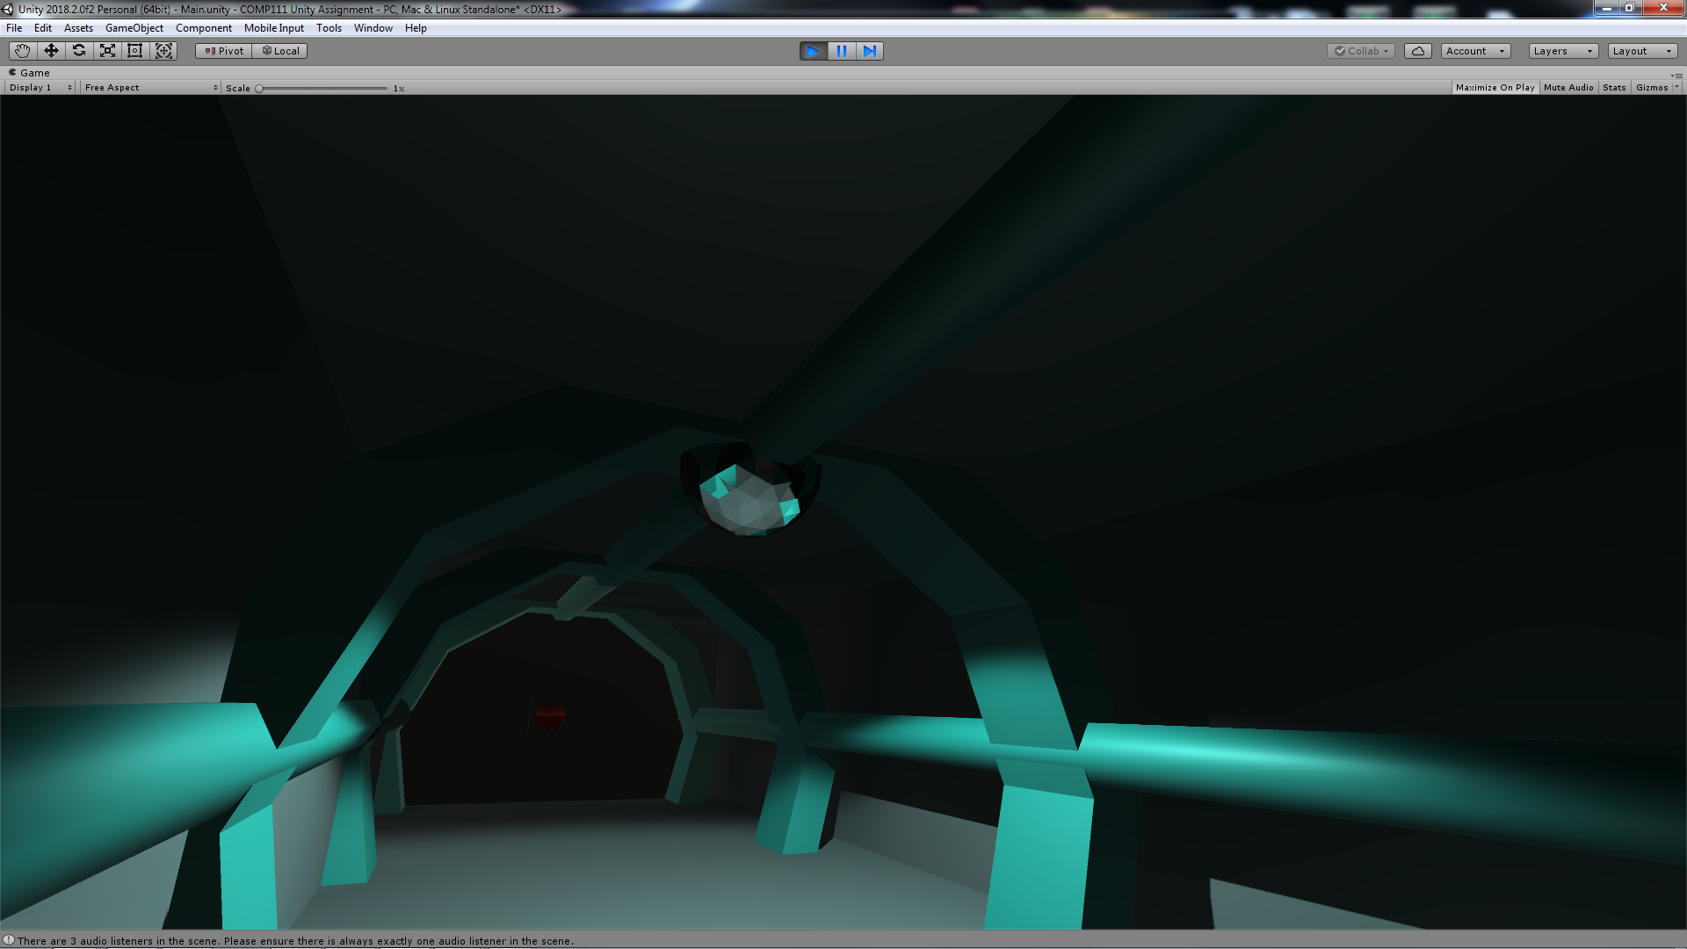

Closer View of the Illumisphere, the forehead of the Player is visible on one of its reflective sides:

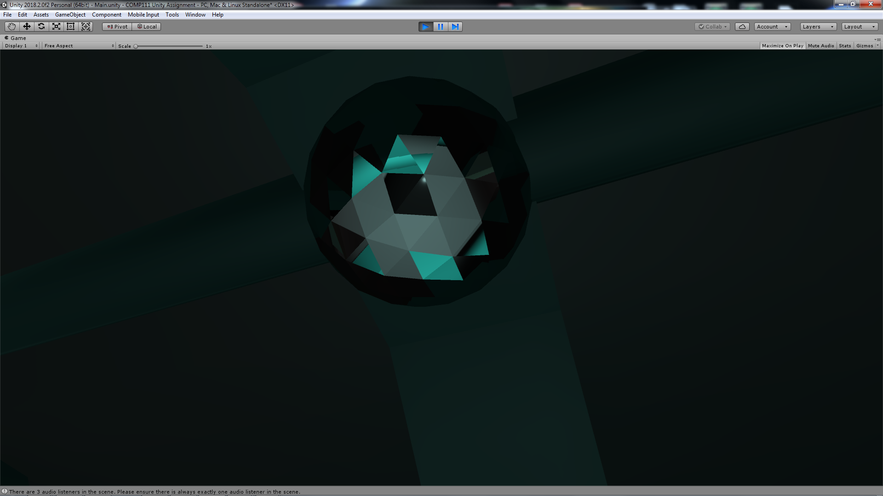

Shadows casted by the Illumisphere:

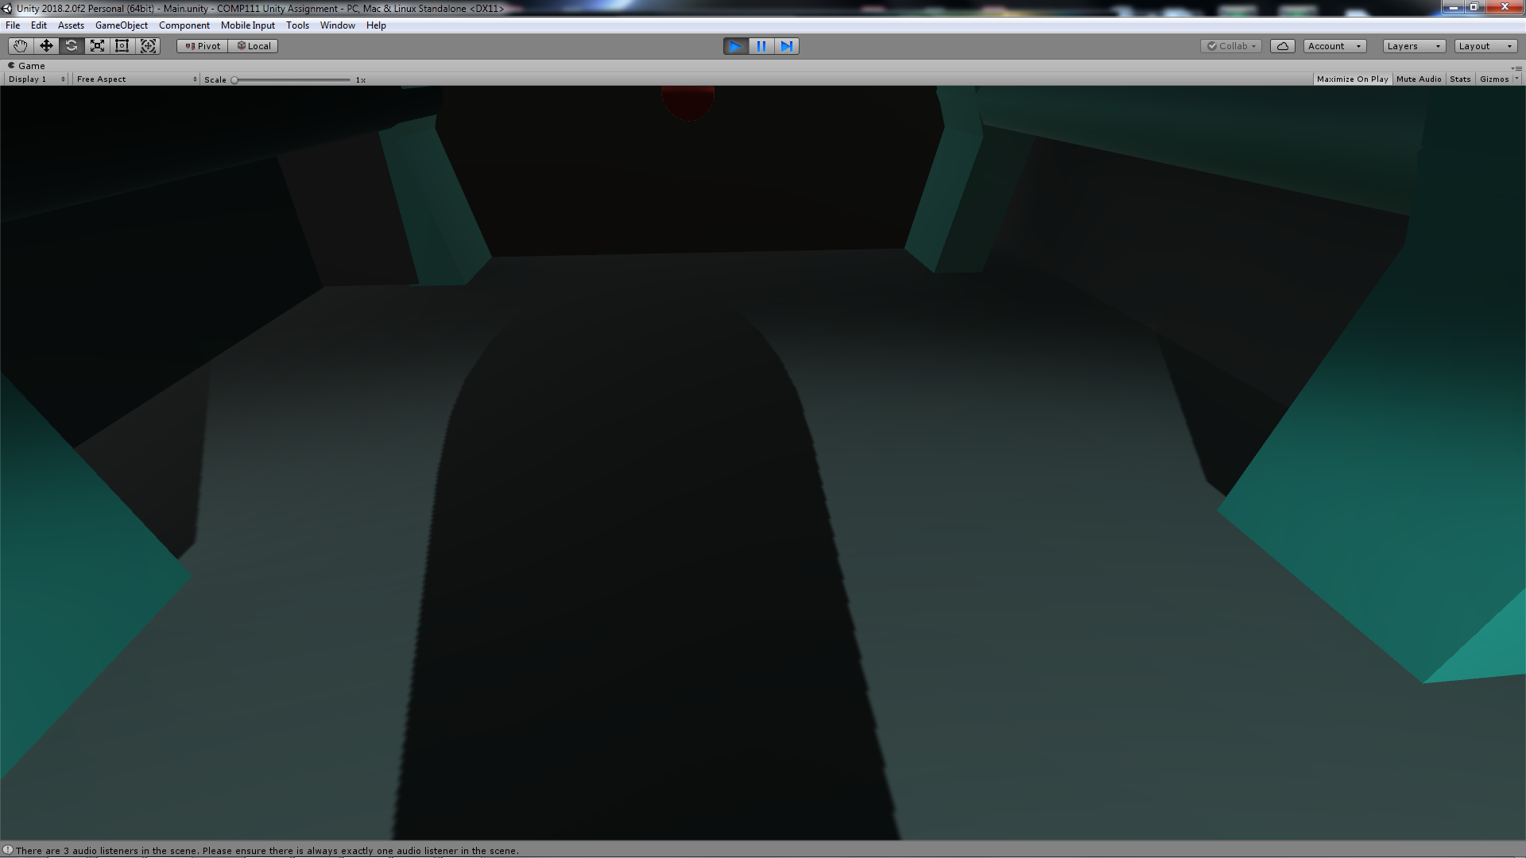

## 4. Baby Monitors

**Features used**:

* Appropriately chosen [post-processing effects](https://docs.unity3d.com/Manual/PostProcessingOverview.html)
* Use of [multiple cameras](https://docs.unity3d.com/Manual/CamerasOverview.html) (e.g. overlaid cameras or rendering to a texture)

**Where in Hierarchy (respectively)**

* /FPSController/FirstPersonCharacter/Screen – Strange (Camera)
* /Shipping Container/Exterior/Wall - Left/Long Portion
* /Shipping Container/Exterior/Door (Hinge)/Actual Door/Screen – Strange

**Description**:

I have used 2 quads in the scene. These quads act as monitors and both are placed on the outside of the Swinging Door. Both monitors are connected to its own camera. The first camera is attached to the FPSController which allows the player to see, this is not connected to my quads. The second is also attached to the player but it is behind the player, looking slight downwards. This connects to the Swinging Door’s monitor (which moves with the Door and hence is a child object of the Door) and has a post-processing effect applied in an attempt to give a creepy stalking camera feel. The third camera is at the start of the tunnel which connects to the quad next to the Swinging Door’s. This looks relatively normal in an attempt to strike a contrast with the creepier camera.

**Screenshot**:

The Baby Monitors

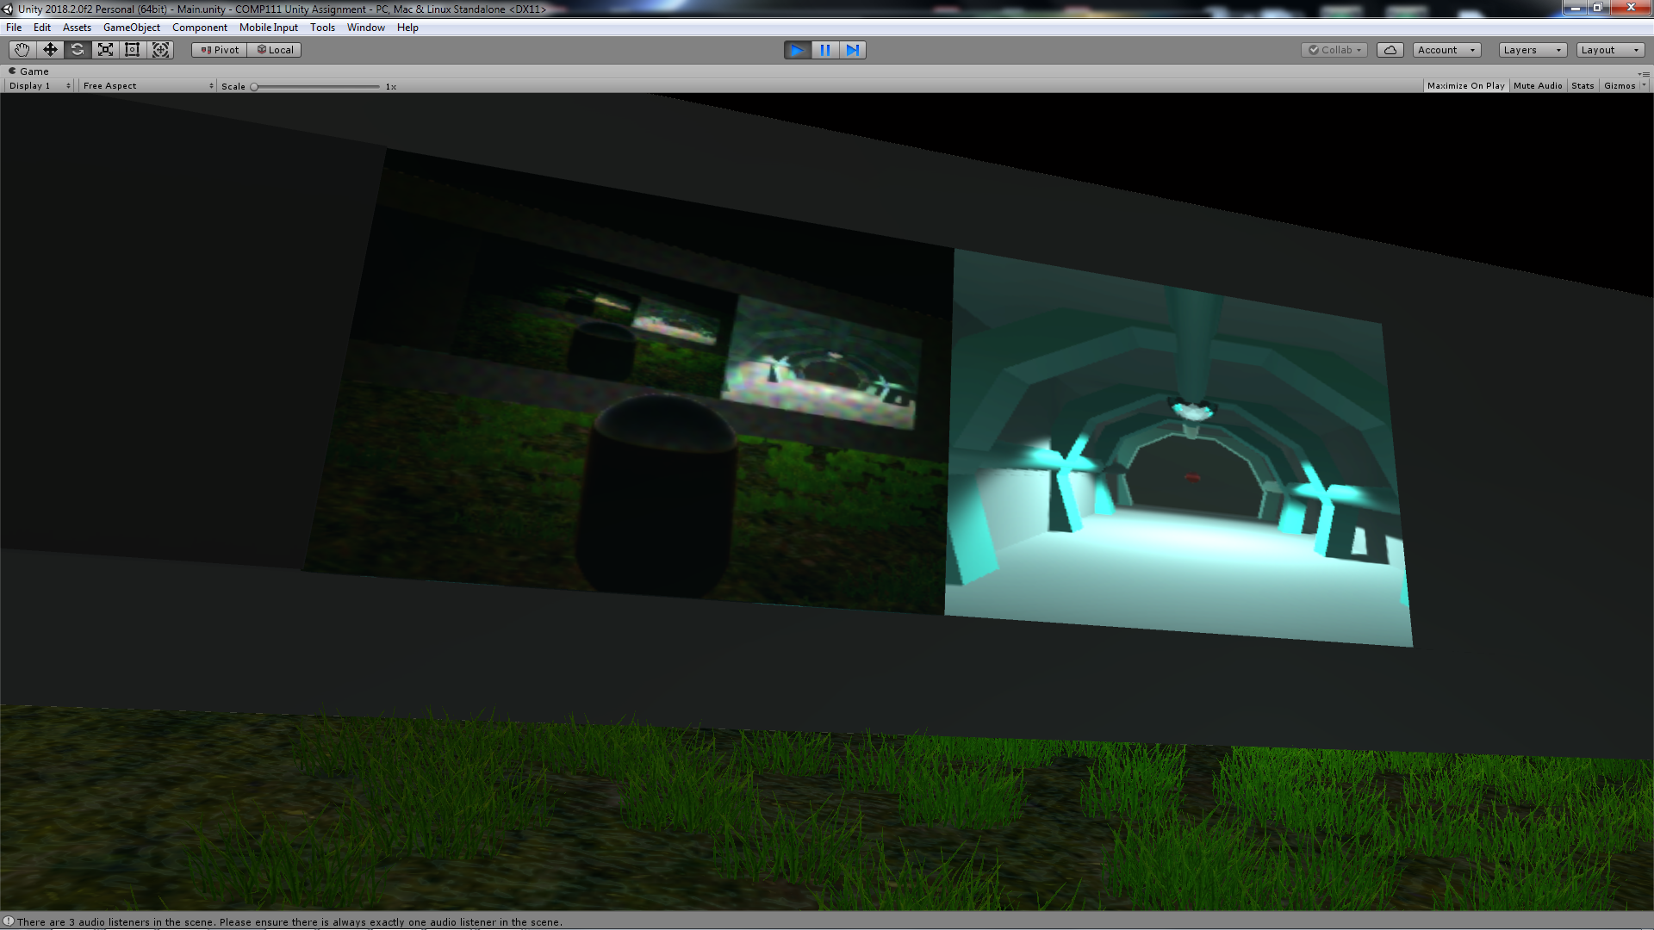

## 5. The Mesmeriser

**Features used**:

* Particle effects
* Direct [light sources](https://docs.unity3d.com/Manual/LightSources.html) beyond the default Directional Light

**Where in Hierarchy**

* /Terrain/Mesmeriser

**Description**:

This is a particle effect system used to produce an effect that looks like the water is floating upwards in droplets. Trails are used to enhance the effect. The droplets also employs the lighting function of the particle system

**Screenshot**:

The Mesme”Riser”:

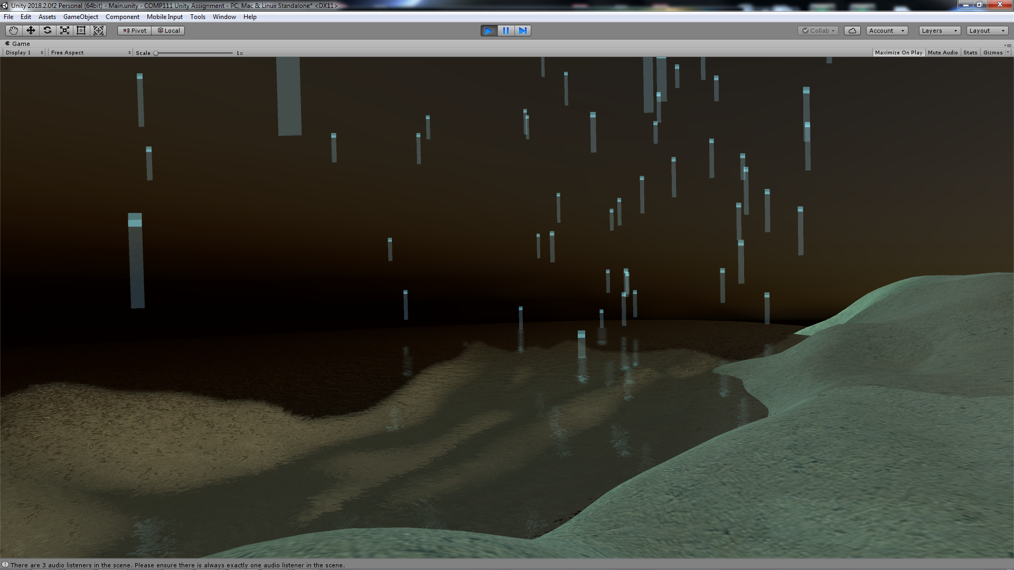

## 6. The Sun

**Features used**:

* A simple single-state [animation clips](https://docs.unity3d.com/Manual/animeditor-UsingAnimationEditor.html)

**Where in Hierarchy**

* /Sun

**Description**:

A day/night cycle made with a simple single-state animation of the direction light.

**Screenshot**:

Sunset with the day/night cycle:

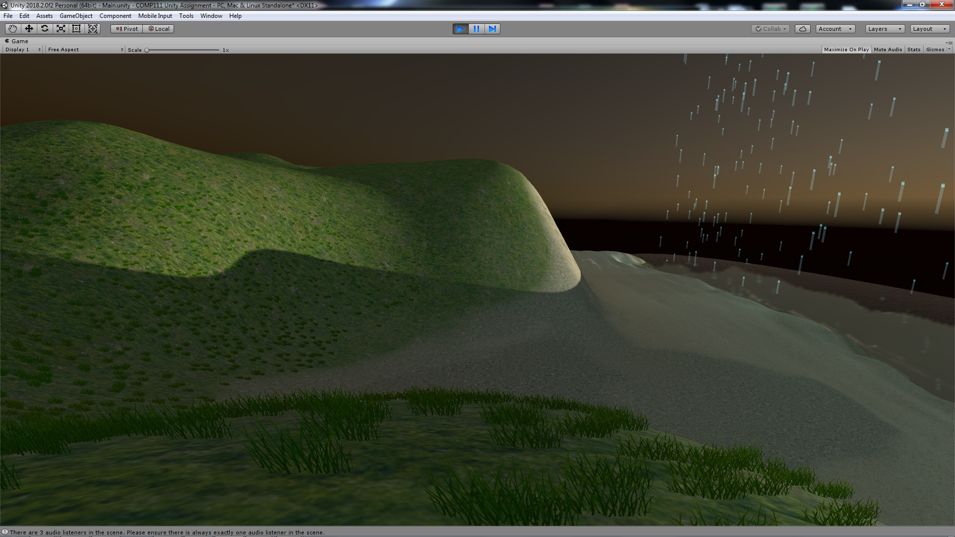

## 6. The Sound

**Features used**:

* Appropriate 3D spatialised [audio sources](https://docs.unity3d.com/Manual/AudioOverview.html)
* Using [reverb zones](https://docs.unity3d.com/Manual/class-AudioReverbZone.html)**,**[effects](https://docs.unity3d.com/Manual/class-AudioEffectMixer.html) and [filters](https://docs.unity3d.com/Manual/class-AudioEffect.html)

**Where in Hierarchy**

* /Background Music
* /Shipping Container/Interior/Reverb Zone
* /Terrain/Water/Reverb Zone

**Description**:

I have used the song “02 la mer” by Henning Philippsen from freeswap.org as my background music. The music plays when the player reaches the vicinity of the beach. Furthermore, there are 2 audio reverb zones in the scene. The first is inside the container which is supposed to make the player’s footsteps echo a little. The second can be found by following the downward slope from the grassland to the beach and walking forward until submerged under water. This reverb zone applies an underwater effect on the background music and the player’s footsteps are heard.

Unfortunately, the reverb zones wouldn’t work for the scene despite many attempts. (I’ve tried replacing the FPSController and Reverb Zones and changing various settings of both.)

**Screenshot**:

Location of the beach where the background music can definitely be heard:

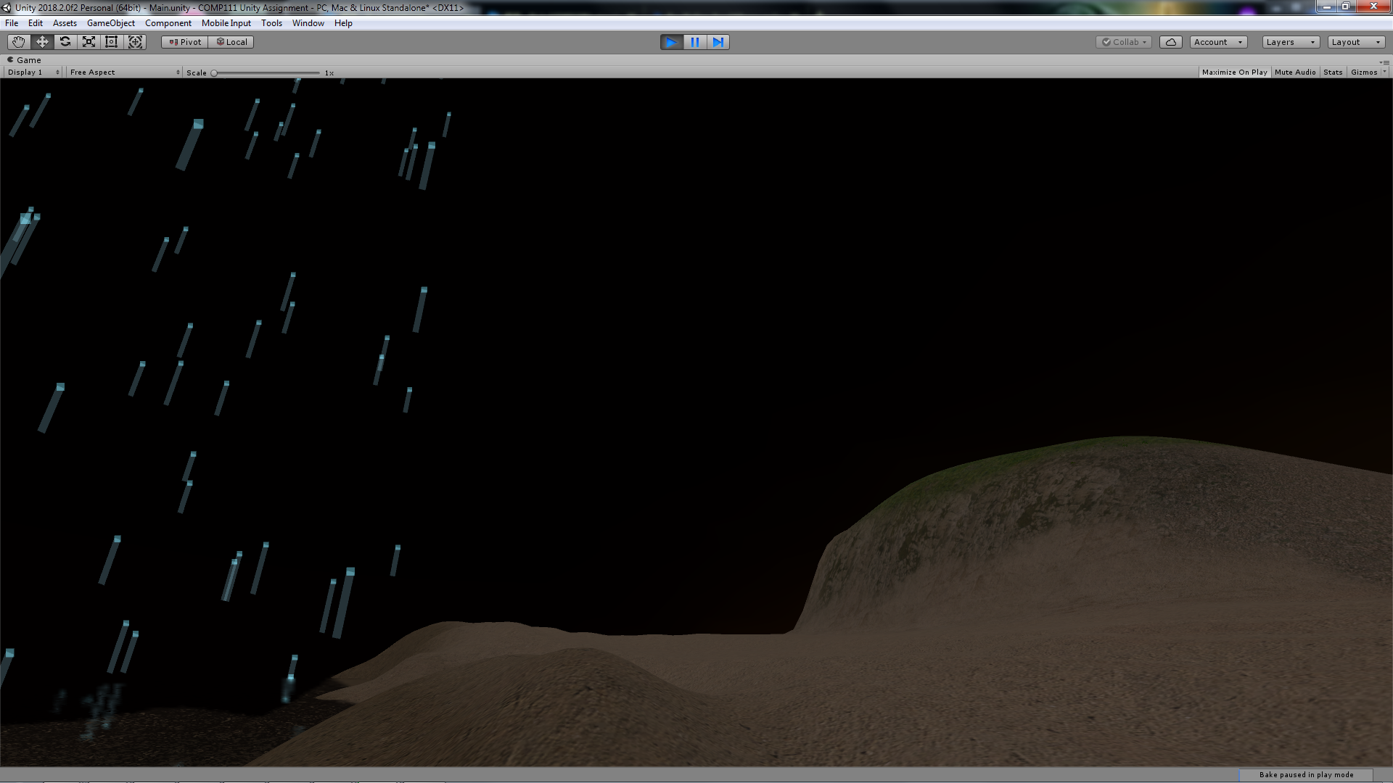

Underwater reverb zone is further underwater, just behind this area where the downward slope of the grassland is roughly in the middle of the field of vision:

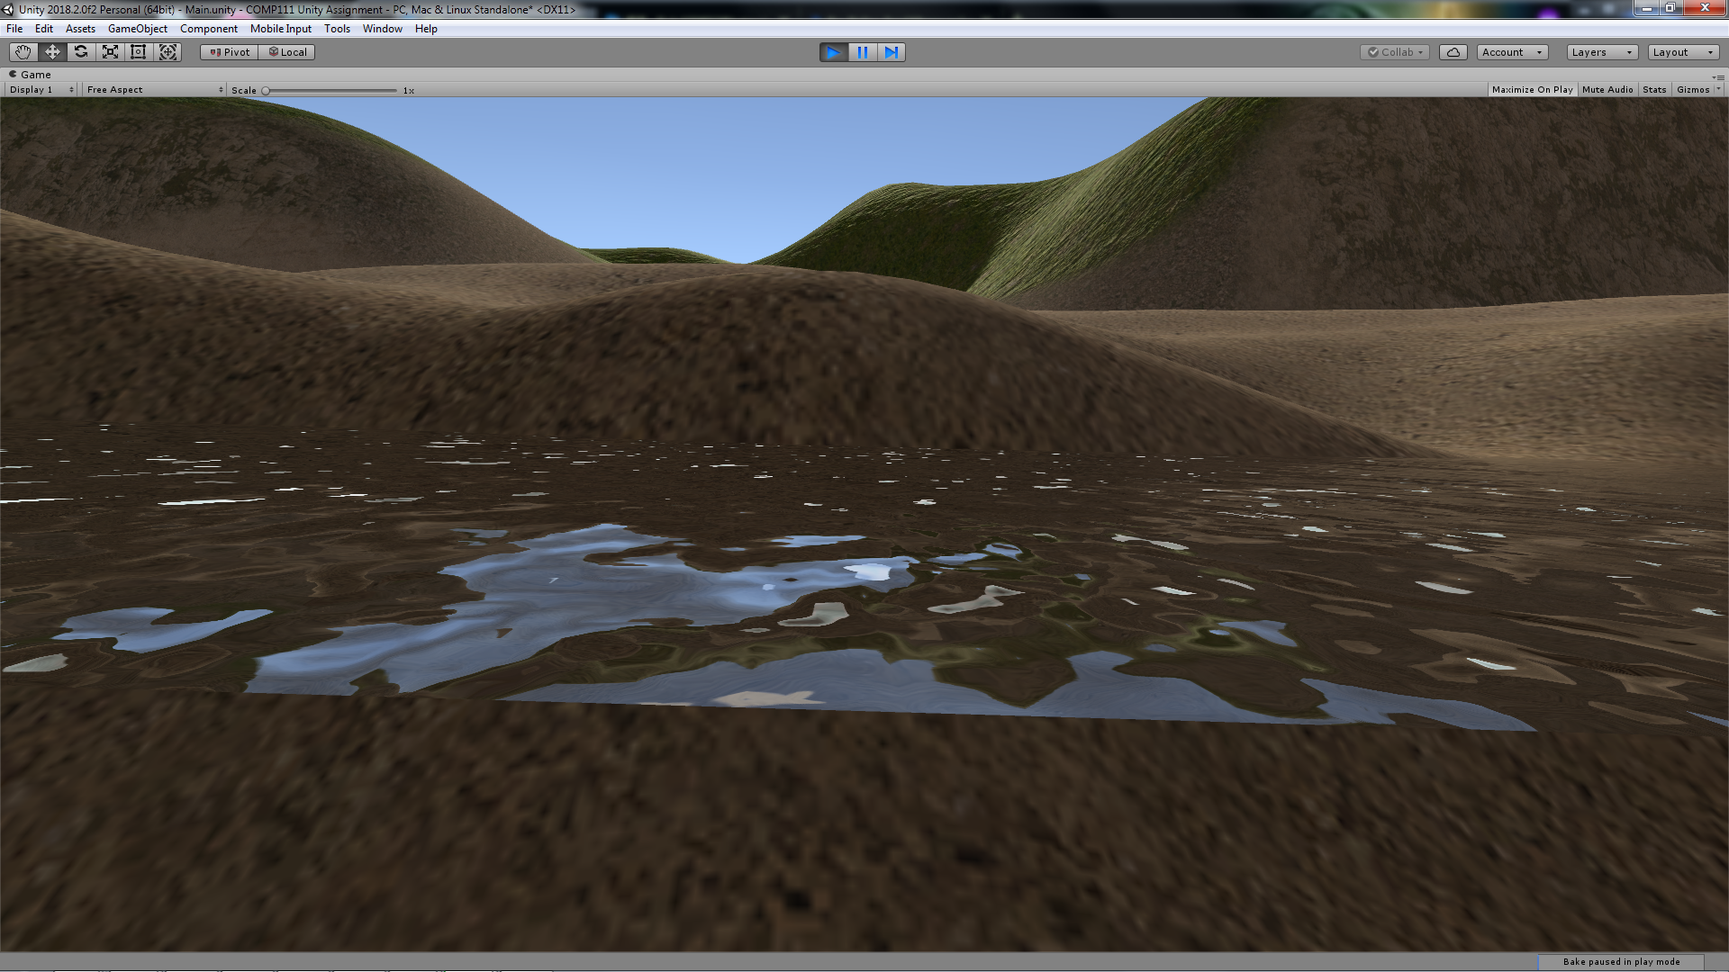

Standing under the Illumisphere should also be where the echoing reverb zone can be best heard: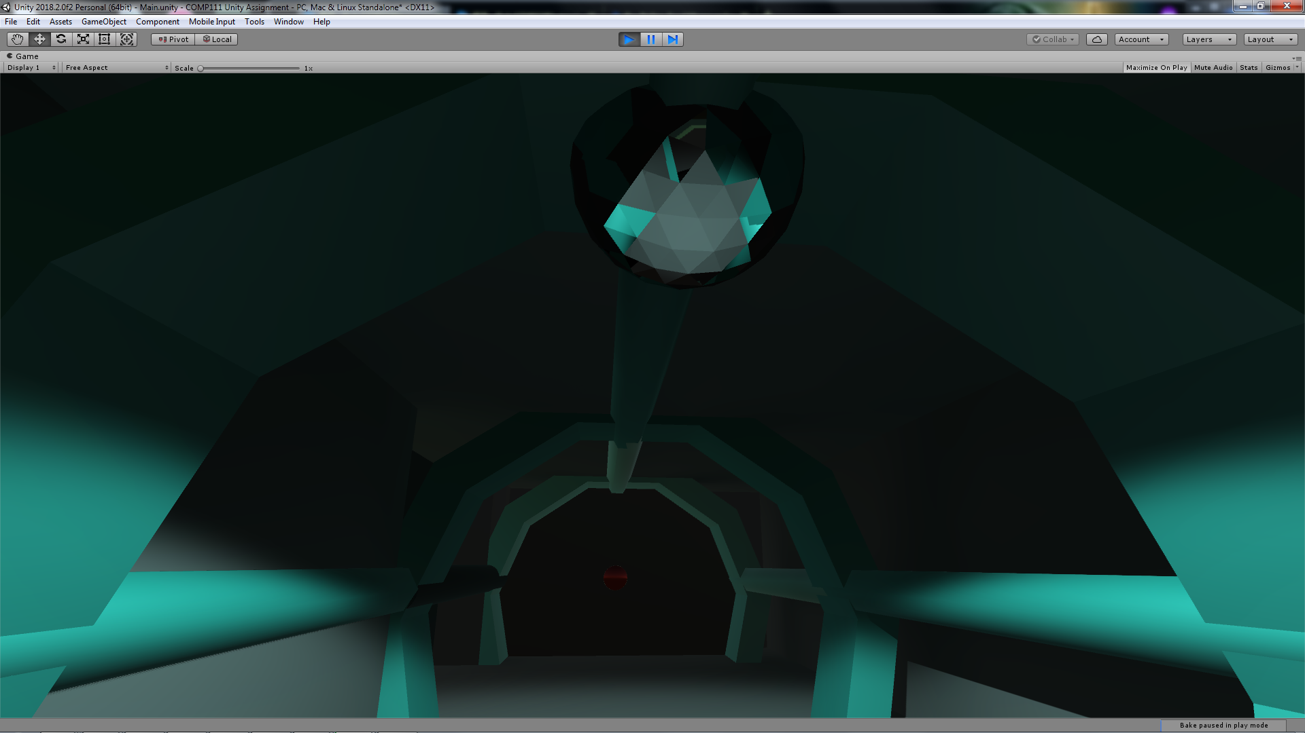

Assets Used

**Terrain Assets**, by Unity Technologies (from Asset Store)

* Terrain
* Entire Terrain Texture
* Grass Billboard

**ProBuilder**, by Unity Technologies (from Asset Store)

* Shipping Container (Tunnel and majority of the Exterior)
* The Illumisphere (lightbulb)

**Standard Assets**, by Unity Technologies (from Asset Store)

* FPSController
* Water of the Terrain

**Post Processing Stack**, by Unity Technologies (from Asset Store)

* Post Processing Effect of Swinging Door’s Quad

**Malcolm’s Textures**, by Malcolm Ryan (Week 6 Prac)

* Normal Map of Grass Texture

**02 la mer**, by Henning Philippsen (from sampleswap.org, URL: [sampleswap.org/mp3/song.php?id=384](http://sampleswap.org/mp3/song.php?id=384))

* Background Music on the Beach